**Identify the product options**

1. IoT enables devices to gather and then relay information for data analysis
2. Smart devices are equipped with sensors that collect data
3. A few common sensors:
   1. Environmental sensors that capture temperature and humidity levels
   2. Barcode, QR code, or optical character recognition (OCR) scanners
   3. Geo-location and proximity sensors
   4. Accelerometer and tilt sensors
   5. Flow, level, and pressure sensors
   6. etc
4. Using Azure IoT services, devices with sensors can connect to the internet and send data via a message
5. Message's data is then collected and aggregated, and it can be converted into reports and alerts

## **Azure IoT Hub**

1. Is a managed service that's hosted in the cloud and that acts as a central message hub for bi-directional communication between your IoT application and the devices it manages
2. You can connect virtually any device to your IoT hub
3. Supports communications both from the device to the cloud and from the cloud to the device
4. Supports multiple messaging patterns:
   1. Device-to-cloud telemetry
   2. File upload from devices
   3. Request-reply methods
5. From a cloud-to-device perspective, IoT Hub allows for command and control. This means either manual or automated remote control
6. Track events such as device creation, device failures, and device connections

## **Azure IoT Central**

1. Builds on top of IoT Hub, by adding a dashboard that allows you to connect, monitor, and manage your IoT devices
2. User interface (UI) makes it easy to quickly connect new devices
3. You can watch the overall performance across all devices, set up alerts and push firmware updates.
4. To help you get up and running quickly, IoT Central provides starter templates
5. You then customize the design starter templates
6. You can use the UI to control your devices remotely

## **Azure Sphere**

1. Creates an end-to-end, highly secure IoT solution
2. For customers that encompasses everything from the hardware and operating system on the device
3. Azure Sphere has built-in communication and security features for internet-connected devices
4. Azure Sphere comes in three parts:
   1. **Azure Sphere micro-controller unit (MCU):** responsible for processing the operating system and signals from attached sensors
   2. **Customized Linux operating system (OS):** Handles communication with the security service
   3. The third part is Azure Sphere Security Service, also known as AS3. Makes sure that the device has not been maliciously compromised. When the device attempts to connect to Azure, it first must authenticate itself, using certificate-based authentication. AS3 checks to ensure that the device hasn't been tampered with.

# Analyze the decision criteria

## **Is it critical to ensure that the device is not compromised?**

1. YES, because no manufacturers or customers want their devices to be maliciously compromised
2. When security is a critical consideration in your product's design, the best product option is Azure Sphere
3. Azure Sphere ensures a secure channel of communication between the device and Azure by controlling everything from the hardware to the operating system and the authentication process
4. This ensures that the integrity of the device is uncompromised

## **Do I need a dashboard for reporting and management?**

1. If you merely want to connect to your remote devices to receive telemetry and occasionally push updates then you can implement Azure IoT Hub by itself
2. However, if you want a pre-built customizable user interface with which you can view and control your devices remotely, you might prefer to start with IoT Central
3. IoT Central integrates with many different Azure products, including IoT Hub, to create a dashboard with reports and management features.

# Use IoT Hub

1. **Scenario:** The devices will not require remote control. They will merely be sending their telemetry data for analysis and pro-active maintenance

## **Which service should you choose?**

1. It's preferable, but not critical, that the devices aren't compromised - No
2. Do I need a dashboard for reporting and management? – No
3. So, given the responses to the decision criteria, Azure IoT Hub is the best choice in this scenario. IoT Central is not needed

## **Why not use Azure IoT Central?**

1. Azure IoT Central provides a dashboard that allows companies to manage IoT devices individually and an aggregate, view reports, and set up error notifications via a GUI
2. In this scenario, Tailwind Traders wants to integrate the telemetry it collects

## **Why not use Azure Sphere?**

1. Azure Sphere provides a complete solution for scenarios where security is critical
2. In this scenario, security is preferred but not critical

# Use IoT Central

1. **Scenario**: The company is looking for a complete logistics solution that takes data sent from an onboard vehicle computer and turns it into actionable information
2. Furthermore, shipments can be outfitted with sensors from a third-party vendor to collect and monitor ambient conditions.
3. The company would prefer a **pre-built solution** to collect the sensor and vehicle computer data, and provide a **graphical user interface** that displays **reports** about shipments and vehicles

## **Which service should you choose?**

1. Does Tailwind Traders need a dashboard for reporting and management? Yes, a reporting and management dashboard is a requirement.

## **Why not use IoT Hub?**

1. The company would need to do a lot of custom development to build its own cloud-based dashboards and management systems on top of Azure IoT Hub.

## **Why not use Azure Sphere?**

1. Azure Sphere provides a complete solution for scenarios where security is critical
2. In this scenario, security is ideal, but not a critical priority

# Use Azure Sphere

1. Tailwind Traders wants to implement a touchless point-of-sale solution for self-checkout. The self-checkout terminals should be, above all else, **secure**
2. Each terminal must be impervious to malicious code that could create fraudulent transactions

## **Which service should you choose?**

1. First, is it critical to ensure that the device or, in this case, each point-of-sale terminal, is not compromised? Absolutely
2. Next, does Tailwind Traders need a dashboard for reporting and management? Yes, the company requires a reporting and management dashboard
3. So, given the responses to the decision criteria, the IoT engineering firm will build a platform on top of both Azure IoT Central and Azure Sphere

## **Why not choose IoT Hub?**

1. By using IoT Central, Tailwind Traders would actually be using Azure IoT Hub behind the scenes as well

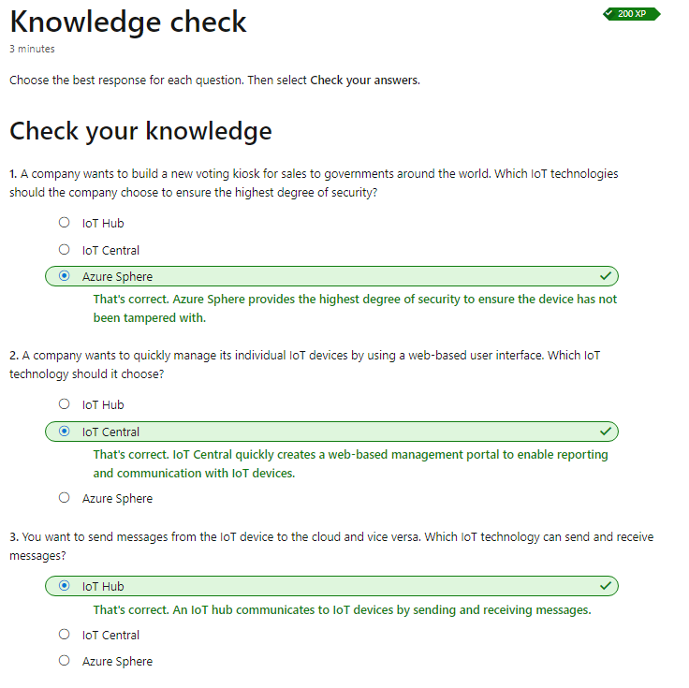

# Identify the product options

1. AI is a broad classification of computing that allows a software system to perceive its environment and take action
2. A goal of AI is to create a software system that's able to adapt, or learn something on its own
3. There are two basic approaches to AI:
   1. Deep learning system that's modeled on the neural network of the human mind
   2. Machine learning, a data science technique that uses existing data to train a model, test it, and then apply the model

## **Azure product options**

1. Three primary product offerings:
   1. **Azure Machine Learning:** Is a platform for making predictions. Consists of tools and services that allow you to connect to data to train and test models to find one that will most accurately predict a future result. After you've run experiments to test the model, you can deploy and use it in real time via a web API endpoint. Choose Azure Machine Learning when your data scientists need complete control over the design and training of an algorithm using your own data With Azure Machine Learning, you can:
      1. Create a process that defines how to obtain, handle and split data
      2. Train and evaluate predictive models by using tools and programming language
      3. Create pipelines
      4. Deploy the best-performing algorithm as an API
   2. **Azure Cognitive Services:** Provides prebuilt machine learning models that enable applications to see, hear, speak, understand, and even begin to reason.  Use Azure Cognitive Services to solve general problems, such as analyzing text for emotional sentiment or analyzing images to recognize objects or faces.  You don't need special machine learning or data science knowledge to use these services. Azure Cognitive Services can be divided into the following categories:
      1. **Language**
      2. **Speech**
      3. **Vision**
      4. **Decision**
   3. **Azure Bot Service:** Creating virtual agents that understand and reply to questions just like a human.  Azure Bot Service is a bit different from Azure Machine Learning and Azure Cognitive Services in that it has a specific use case. The bot you build uses other Azure services, such as Azure Cognitive Services, to understand what their human counterparts are asking for.

# Analyze the decision criteria

1. Are you building a virtual agent that interfaces with humans via natural language? - **Azure Bot Service**
2. Do you need a service that can understand the content and meaning of images, video, or audio, or that can translate text into a different language? - **Use Azure Cognitive Services**
3. Do you need to predict user behavior or provide users with personalized recommendations in your app? - **Azure Cognitive Services Personalizer**
4. Will your app predict future outcomes based on private historical data? **Azure Machine Learning**
5. Do you need to build a model by using your own data or perform a different task than those listed above? **Azure Machine Learning with deep learning**

# Use Machine Learning for decision support systems

1. **Scenario:** e-commerce website allows its customers to browse and purchase items that can be delivered or picked up from a retail store nearest to their location. The Marketing team is convinced that it can increase sales dramatically by suggesting add-on products that complement the items in a shopper's cart at the point of checkout. Additionally, the suggestions could be influenced by product availability, product profitability, and other factors.

## **Which service should you choose?**

1. Is Tailwind Traders building a virtual agent that interfaces with humans via natural language? No
2. Second, does Tailwind Traders need a service that can understand the content and meaning of images, video, audio, or translate text into a different language? No
3. Third, does Tailwind Traders need to predict user behavior or provide users with personalized recommendations? Yes
4. Fourth, will the Tailwind Traders app predict future outcomes based on private historical data? Yes
5. Finally, it sounds like the Marketing team already employs some data science experts, and the team is willing to make at least a year-long commitment to building, testing, and tweaking the models to be used.

# Use Cognitive Services for data analysis

1. **Scenario:** With the company website, only 80% of the customers speak English. The team sees the addition of multiple languages as a wonderful opportunity to serve non-English speakers with the same online e-commerce experience as English speakers.

## **Which service should you choose?**

1. First, is Tailwind Traders building a virtual agent that interfaces with humans via natural language? No
2. Second, does Tailwind Traders need a service that can understand the content and meaning of images, video, audio, or translate text into a different language? Yes
3. Third, does Tailwind Traders need to predict user behavior or provide users with personalized recommendations? No
4. Finally, will the Tailwind Traders app need to predict future outcomes based on private historical data? No

# Use Bot Service for interactive chat experiences

1. The Customer Service team has long asked for a virtual agent to handle the vast majority of questions it gets asked. The team wants shoppers to feel as though they're interacting with a real human. When it becomes clear that the virtual agent can't provide an answer, the chat session should be transferred to a human.

## **Which service should you choose?**

1. First, is Tailwind Traders building a virtual agent that interfaces with humans via natural language? Yes
2. Second, does Tailwind Traders need a service that can understand the content and meaning of images, video, audio, or translate text into a different language? Possibly, yes
3. Third, does Tailwind Traders need to predict user behavior or provide users with personalized recommendations? No
4. Finally, will the Tailwind Traders app need to predict future outcomes based on private historical data? No

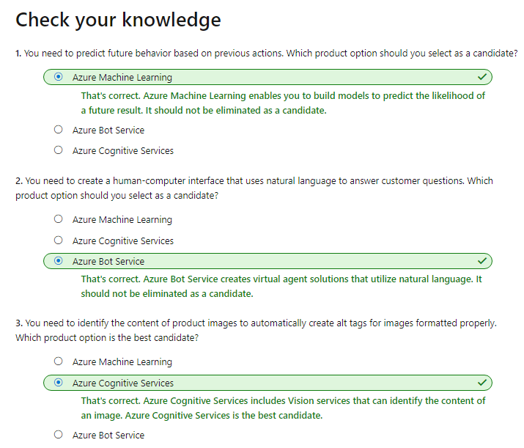

# Identify the product options

1. The term serverless computing is a misnomer. After all, there is a server
2. The key idea is that you're not responsible for setting up or maintaining the server
3. You create an instance of the service, and you then add your code
4. Respond to events
5. An event could be a **REST endpoint,** **a periodic timer**, or even a **message received** from another Azure service
6. Serverless computing is ordinarily used to **handle back-end scenarios**

## **Azure Functions**

1. With Azure Functions, you can host a single method or function by using a popular programming language in the cloud
2. Written in many common programming languages, such as C#, Python, JavaScript, Typescript, Java, and PowerShell
3. Azure Functions scales automatically, and charges accrue only when a function is triggered
4. An Azure function is a stateless environment, a function behaves as if it's restarted due to an event
5. Ideal when you're concerned only with the code

## **Azure Logic Apps**

1. Low-code/no-code development platform
2. The service helps you automate and orchestrate tasks, business processes, and workflows
3. Logic Apps simplifies how you design and build scalable solutions,
4. This solution covers app integration, data integration, system integration, enterprise application integration (EAI), and business-to-business (B2B) integration
5. Azure Logic Apps is designed in a web-based designer and can execute logic that's triggered by Azure services
6. without writing any code
7. You build an app by linking triggerss

## **What are the differences between these services?**

1. Primary difference is their intent
2. Azure Functions is a serverless,  Azure Logic Apps is intended to be a serverless orchestration service
3. The two services are priced differently
4. ***Azure Functions*** ***pricing*** is based on the ***number of executions*** and the ***running time*** of each execution
5. ***Logic Apps pricing*** is based on the ***number of executions*** and the ***type of connectors that it utilizes***.

# Analyze the decision criteria

1. **Do you need to perform an orchestration across well-known APIs?**
   1. Logic Apps excels at connecting a large array of disparate services via their APIs
   2. Azure Logic Apps has already componentized these API calls so that you supply only a few details
   3. It's possible to create the same workflow by using Azure Functions, but it might take a considerable amount of time
2. **Do you need to execute custom algorithms or perform specialized data parsing and data lookups?**
   1. With Azure Functions, you can use the full expressiveness of a programming language in a compact form
   2. This lets you concisely build complex algorithms, or data lookup and parsing operations
   3. You would be responsible for maintaining the code
   4. Although Azure Logic Apps can perform logic (loops, decisions, and so on), if you have a logic-intensive orchestration
3. **Do you have existing automated tasks written in an imperative programming language?**
   1. If you already have your orchestration or business logic expressed ina popular programming language, it might be easier to port your code into Azure Functions function app than to re-create it by using Azure Logic Apps
4. **Do you prefer a visual (declarative) workflow or writing (imperative) code?**
   1. Developers – Functions
   2. IT professionals and business analysts – Logic Apps

# Use Azure Functions

1. **Scenario:** 
   1. Retrieve the messages.
   2. Parse the JSON.
   3. Perform a lookup across multiple databases to find additional product information.
   4. Potentially, send notifications to the purchasing department so that they can reorder quantities that fall below certain levels.
2. In this case port it to an Azure function
3. Why not choose Azure Logic Apps:
   1. Team has already invested time in building the service in C#, it can use the same code in an Azure function

# Use Azure Logic Apps

1. **Scenario:**
   1. Unfortunately, no Tailwind Traders developer resources are available to take on this project. But the customer service team works with several cloud and IT professionals who might be able to construct a solution.
   2. **Which service should you choose?**
      1. Because Azure Logic Apps is a low-code/no-code service, no developers are needed
   3. **Why not choose Azure Functions?**
      1. This approach might be a challenge if no software developers can be committed to this project
      2. This is an ideal scenario for Azure Logic Apps.

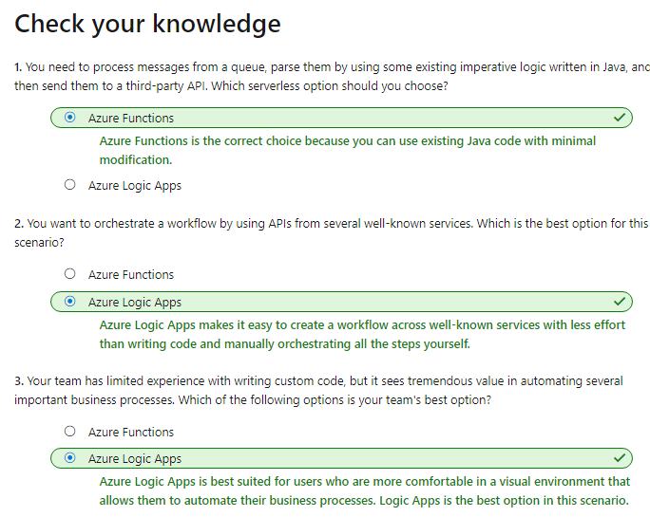

# Understand your product options

1. DevOps is a new approach that helps to align technical teams as they work toward common goals
2. Organizations employ practices and processes that seek to automate the ongoing development, maintenance, and deployment of software systems
3. Aim is to expedite the release of software changes, ensure the ongoing deployability of the system, and ensure that all changes meet a high quality bar
4. When done correctly, DevOps practices and processes touch nearly every aspect of the company
5. DevOps requires a fundamental mindset change from the top down

### **Azure DevOps Services**

1. **Azure Repos:** centralized source-code repository
2. **Azure Boards:** Agile project management suite that includes ***Kanban******boar*ds**, ***reporting***, and ***tracking*** ***ideas***
3. **Azure Pipelines:**  CI/CD pipeline automation tool (CD – Continuous Delivery)
4. **Azure Artifacts:** Repository for hosting artifacts, such as compiled source code
5. **Azure Test Plans:** Automated test tool

### **GitHub and GitHub Actions**

1. Most popular code repository for open-source software
2. Git is a decentralized source-code management tool, and GitHub is a hosted version of Git
3. Following functionality:
   1. Shared source-code repository
   2. Facilitates project management, including Kanban boards
   3. Supports issue reporting, discussion, and tracking
   4. Features CI/CD pipeline automation tooling
   5. Includes a wiki
   6. Can be run from the cloud or on-premises
4. GitHub Actions enables workflow automation with triggers for many lifecycle events, eg ***ToolChain***
5. A toolchain is a combination of software tools that aid in the delivery, development, and management of software applications throughout a system's development lifecycle

### **Azure DevTest Labs**

1. Azure DevTest Labs provides an automated means of managing the process of ***building***, ***setting*** up, and ***tearing*** down virtual machines ***(VMs)***
2. This way, developers and testers can perform tests across a variety of environments and builds
3. Anything you can deploy in Azure via an ARM template (Azure Resource Manager)
4. Suppose you need to test a new feature on an old version of an operating system. Azure DevTest Labs can set up everything automatically upon request

# Analyze the decision criteria

1. **Do you need to automate and manage test-lab creation?**
   1. Consider choosing Azure DevTest Labs
   2. It's the only one that offers this functionality
2. **Are you building open-source software?**
   1. GitHub has long been the preferred host for open-source software
3. **Regarding source-code management and DevOps tools, what level of granularity do you need for permissions?**
   1. Azure DevOps has a much more granular set of permissions over GitHub
4. **Regarding source-code management and DevOps tools, how sophisticated does your project management and reporting need to be?**
   1. Azure DevOps excels here over GitHub
5. **Regarding source-code management and DevOps tools, how tightly do you need to integrate with third-party tools?**
   1. DevOps tools create hooks or APIs that can be used by both Azure Pipelines and GitHub Actions

# Use Azure DevOps to manage the application development lifecycle

1. **Scenario:**  The team needs to give project sponsors and managers executive level ***reporting***, including burndown ***charts***, track progress against epics, and track custom information that's specific to Tailwind Traders in each work item and ***bug*** ***report***.
2. **Which services should we choose?**
   1. First, does Tailwind Traders need to automate and manage test lab creation? ***No***. So, in this scenario, Azure DevTest Labs is not a candidate
   2. Second, is Tailwind Traders building open-source software? ***No***
   3. Third, what level of granularity does Tailwind Traders need for permissions? ***Yes.*** Therefore Azure DevOps is the leading candidate
   4. Fourth, does Tailwind Traders require a sophisticated project management and reporting solution? ***Yes*** – Therefore use DevOps
   5. Fifth, does Tailwind Traders require tight integration with any third-party DevOps tools? Not specified – Use Azure DevOps or GitHub

# Use GitHub to contribute to open-source software

1. **Scenario:** Tailwind Traders hopes to publish an API. The team needs a platform to share example code, collect feedback on the API, allow contributors to report issues, and build a community around feature requests.
2. **Which service should you choose?**
   1. First, does Tailwind Traders need to automate and manage test lab creation? ***No***
   2. Second, is Tailwind Traders building open-source software? ***Yes – GitHub***
   3. Third, what level of granularity does the Tailwind Traders team need for assigning permissions? ***Not stated.*** Permissions needs are basic, therefore ***GitHub*** is fine
   4. Fourth, does Tailwind Traders require a sophisticated project management and reporting solution?
   5. Fifth, does Tailwind Traders require tight integration with any third-party DevOps tools? Not specified

# Use Azure DevTest Labs to manage testing environments

1. **Scenario:** Team has concerns around the costs of a more automated test environment. Wants to make sure that the QA professionals are not wasting time configuring the testing environment to match the production environment.
2. **Which service should you choose?**
   1. First, does Tailwind Traders need to automate and manage test lab creation? ***Yes*** - Azure DevTest Labs

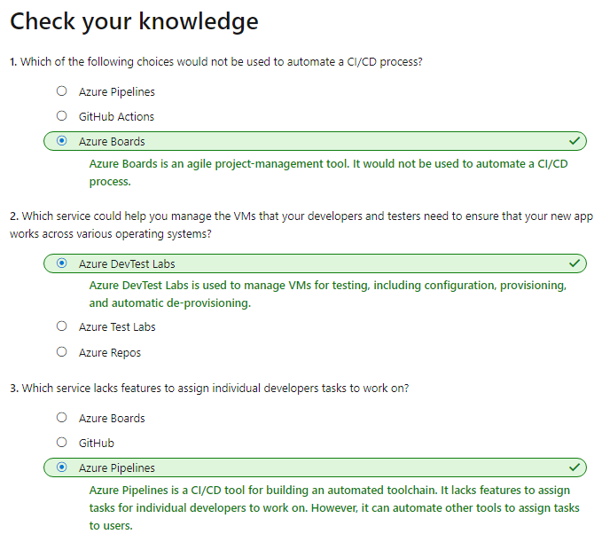

**TOOLS FOR MANAGING THE AZURE ENVIRONMENT**

# Identify the product options

1. Two broad categories of management tools:
   1. **Visual tools:** Visual tools provide full, visually friendly access to all the functionality of Azure. Might be less useful when you're trying to set up a large deployment of resources
   2. **Code-based tools:**  Attempting to quickly set up and configure Azure resources, a code-based tool is usually the better choice. Although it might take time to understand the right commands and parameters at first, after they've been entered, they can be saved into files. Code that performs setup and configuration can be stored, versioned, and maintained, known as infrastructure as code.
   3. **There are two approaches to infrastructure as code:**
      1. Imperative *code:*  Details each individual step
      2. *Declarative code:* Details only a desired outcome. Declarative code can provide a more robust approach to deploying dozens or hundreds of resources simultaneously and reliably.

## **Your product options**

1. **The Azure portal:** By using the Azure portal, a web-based user interface, you can access virtually every feature of Azure. Provides a friendly, graphical UI to view all the services. The Azure portal is how most users first experience Azure. As your Azure usage grows, you'll likely choose a more repeatable code-centric approach.
2. **The Azure mobile app:** Provides iOS and Android access to your Azure resources. With it you can: 1) Monitor the health and status of resources. 2) Check for alerts, quickly diagnose and fix issues. 3) Run the Azure CLI or Azure PowerShell commands
3. **Azure PowerShell:**  Available for Windows, Linux, and Mac, and you can access it in a web browser via Azure Cloud Shell. Developers and DevOps and IT professionals can execute commands called **cmdlets.** Cmdlets can be executed independently or combined into a script file to:
   1. For routine setup, teardown, and maintenance
   2. Deployment of an entire infrastructure
4. **The Azure CLI:** Executable program with which a developer, DevOps professional, or IT professional can execute commands in **Bash.**
5. **ARM templates:** Although it's possible to write imperative code in Azure PowerShell or the Azure CLI, there is a better way.With (ARM templates), you can describe the resources you want to use in a declarative JSON format.

# Analyze the decision criteria

1. **Do you need to perform one-off management, administrative, or reporting actions?**
   1. ***Azure PowerShell*** and ***the Azure CLI*** are Azure management tools that allow you to ***quickly*** ***obtain*** the ***IP address*** of a ***virtual machine (VM)*** you've deployed, ***reboot*** a VM, or ***scale*** an app
   2. ***Azure CLI and PowerShell, Azure Resource Manager*** templates (ARM templates) define the infrastructure requirements in your application for ***repeatable*** ***deployments***
   3. The ***Azure portal*** can perform most, if not all, management and administrative actions.  If you're just learning Azure.
   4. For advanced users, Azure CLI or PowerShell will give you the most flexibility
   5. ***Azure mobile app***, which you can access via an ***iOS*** or ***Android phone*** or ***tablet***
2. **Do you need a way to repeatedly set up one or more resources and ensure that all the dependencies are created in the proper order?**
   1. ***ARM templates*** define your application's infrastructure requirements for a ***repeatable deployment*** that is done in ***a consistent manner***
   2. However it is possible to use PowerShell or the Azure CLI to set up all the resources for a deployment, but there is no validation steps.
3. **When you're scripting, do you come from a Windows administration or Linux administration background?**
   1. Windows – Powershell
   2. Linux **–** Azure CLI

# Use the Azure portal to visually understand and manage your cloud environment

1. **Scenario:** Managers or CTO would be able to see the data displayed visually, but also be able to run custom reports in real time.
2. **Which service should you choose?**
   1. First, in this scenario, does Tailwind Traders need to perform one-off management, administrative, or reporting actions? **Yes – Azure Portal**
   2. The next two decision criteria don't apply to this scenario, because the director of cloud operations and the CFO won't be deploying or configuring any resources.

# Use Azure PowerShell for one-off administrative tasks

1. **Scenario:** The team comes from a Windows development, and moved its applications to the cloud, and it now needs a way to perform **one-off testing**, **management**, and **administrative tasks** in its intranet environment
2. **Which service should you choose?**
   1. First, in this scenario, does the Tailwind Traders team need to perform one-off management, administrative, or reporting tasks? **Yes**.
   2. Second, in this scenario, does Tailwind Traders need a repeatable and reliable means of deploying its entire infrastructure? **No**
   3. Due to theWindows administration background – **Powershell**

# Use the Azure CLI for one-off administrative tasks

1. **Scenario**: This team has a Linux administration background and need to perform administrative tasks related to the health of the cloud environment
2. **Which service should you choose?**
   1. The Azure CLI

# Use the Azure mobile app to manage Azure on the go

1. **Scenario:** Director wants to relax this requirement and allow employees to spend these dates with their families. Is there a product that can help support this scenario?
   1. First, does Tailwind Traders need to perform one-off management, administrative, reporting actions? **Yes**
   2. The real question is, how? A phone or tablet solution could help key employees keep an eye on the health of the cloud environment
   3. The Azure mobile app is the right choice.

# Use ARM templates to deploy an entire cloud infrastructure

1. **Scenario**: The company needs a repeatable, reliable way to scale its operations during peak sales periods. The company needs a repeatable, reliable way to scale its operations during peak sales periods. Creates all dependencies in the correct order. Can be used without worrying that it failed in the middle.
2. **Which service should you choose?**
   1. First, in this scenario, does Tailwind Traders need to perform one-off management, administrative, or reporting actions? This time, we're not looking to support one-time or one-off management or administration tasks. We're looking for a technology to automate
   2. Second, does Tailwind Traders need a repeatable and reliable way to deploy its entire infrastructure? **Yes – ARM Templates**
   3. The third decision criterion assumes that you need to write a script by using imperative code. However, when you use ARM templates, you define your infrastructure declaratively by using JSON code.

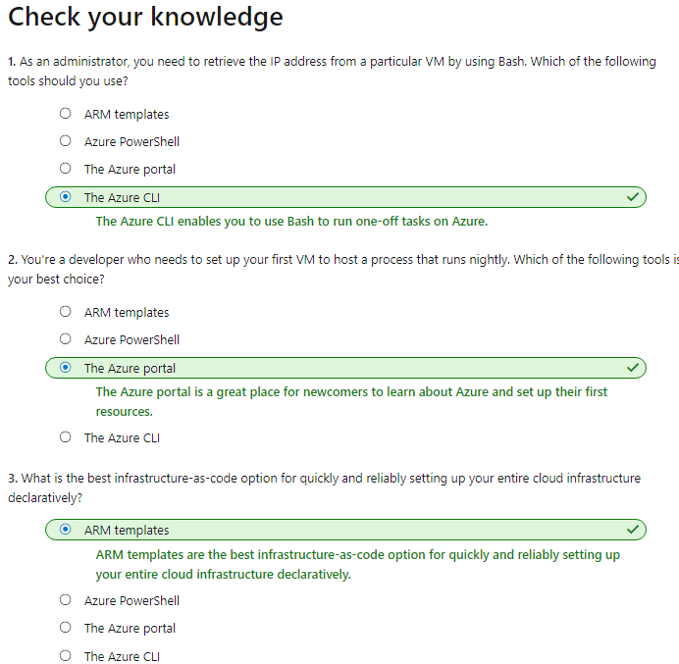

### [Choose the best monitoring service for visibility, insight, and outage mitigation](https://docs.microsoft.com/en-us/learn/modules/monitoring-fundamentals/?ns-enrollment-type=LearningPath&ns-enrollment-id=learn.az-900-describe-core-solutions-management-tools-azure)

# Identify your product options